Math 10

Lesson 4–7 Answers

**Lesson Questions**

**Question 1**



a) b)



**Question 2**

a) To determine the *x*-intercept set *y* = 0: To determine the *y*-intercept set x = 0:

 

–6

–4

4

–4

–2

2

–2

–8

*x*

*y*

•

•

b)

**Question 3**

Rearrange the equation into slope-intercept form:



**Question 4**

a) examples: (2, 27), (4, 24), (6, 21)

b)

6

2

4

–4

–2

2

4

–2

*x*

*y*

•

•

c) 3*x* + 2*y* – 60 = 0

d)

i) Can each of 2 pieces be 18 cm long and each of 3 pieces be 3 cm long?

 **no**

ii) Can each of 2 pieces be 3 cm long and each of 3 pieces be 18 cm long?

 **yes**

**Assignment**

1. Find the x and y intercepts, plot these points, draw a line through the points.

2. In slope-intercept form one can see the y intercept and plot that point. from that point one can do the rise over run and find a second point. The line can be drawn through the two plotted points.

3. a) Standard form

b) General form

c) Slope-intercept form

d) Slope-point form

4. a) *x*-intercept: 3; *y*-intercept: –8

b) *x*-intercept: 8; *y*-intercept: –7

c) *x*-intercept: 22; *y*-intercept: –8

d) *x*-intercept: 13.5; *y*-intercept: –3

5. a) 4*x* + 3*y* – 36 = 0

b) 2*x* – *y* – 7 = 0

c) 2*x* + *y* – 6 = 0

d) 5*x* – *y* – 1 = 0

6. a) b)

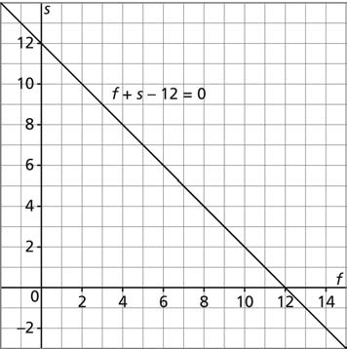7. b)

c) *f* + *s* – 12 = 0

d) Pairs of integers may vary. For example: 0 and 12; 5 and 7; 3 and 9; 13 and –1; 14 and –2; 15 and –3

8. a), b) Letters for the variables may differ.

Let *s* represent a small pan, and *l* represent a large pan.

12*s* + 36*l* = 504

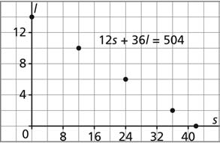

9. a) –4

b) 3

c) 5

d) –5

10. a) 9 pieces of 8-ft. pipe

b) 12 pieces of 6-ft. pipe

c) No; 9.75 pieces of 8-ft. pipe would be needed

d) No; 10pieces of 6-ft. pipe would be needed

11. Screens may vary.

a) b) c) d)

12. a) *x* – 3*y* – 12 = 0

b) *x* – 3*y* + 11 = 0

c) *x* + 4 *y* + 11 = 0

d) 9*x* + 6 *y* – 8 = 0

13. a) The line goes through the origin (0,0) therefore there is only one point.

b)



14. Equations in parts b, e, and g are equivalent. Equations in parts d, f, and h are equivalent.

15. a) 3*x* + 4 *y* – 12 = 0 ; linear function

b) Not a linear function

c) Not a linear function

d) *x* – 3*y* + 8 = 0 ; linear function

16. a) 

b) 